

| **Title:** Implementation of Goal based agent architecture using PROLOG. |
| --- |

**______________________________________________________________________ Objective:** To use the concepts of knowledge engineering to design and solve moderate complex problem.

**______________________________________________________________________**

**Expected Outcome of Experiment:**

| **Course Outcome** | **After successful completion of the course students should be able to** |
| --- | --- |
| **CO1** | Design AI solution with appropriate choice of agent architecture |
| **CO3** | Represent and formulate the knowledge to solve the problems using various reasoning techniques |

**______________________________________________________________________**

**Books/ Journals/ Websites referred:**

1. **https://www.csupomona.edu/~jrfisher/www/prolog_tutorial/contents.html**
2. **http://www.csupomona.edu/~jrfisher/www/prolog_tutorial/pt_framer.html**
3. **http://www.doc.gold.ac.uk/~mas02gw/prolog_tutorial/prologpages/**
4. **http://classes.soe.ucsc.edu/cmps112/Spring03/languages/prolog/PrologIntro.pdf**
5. **“Prolog: Programming for Artificial Intelligence” by Ivan Bratko, Pearson education Publications**
6. **“Artificial Intelligence: a Modern Approach” by Russel and Norving, Pearson education Publications**
7. **“Artificial Intelligence” By Rich and knight, Tata Mcgraw Hill Publications**

**______________________________________________________________________**

**Pre Lab/ Prior Concepts:**

Agents, Agent Architecture, Programming with PROLOG

**______________________________________________________________________**

**Historical Profile:**

Knowledge is vast, uncertain and continuously changing. These properties of knowledge make it difficult to arrive at a result. A murder mystery is a kind of situation which depicts the uncertain nature of knowledge and also emphasizes the need of choosing right clauses from entire knowledgebase to make a decision. He goal based agent architecture and some knowledge engineering can help in solutioning of such problems.

The logical agents are complex but they can reason and learn from the actions and new precepts. They are less like acting and think like humans but more like acting and thinking rational agents.

Knowledge and reasoning play a crucial role in dealing with partially observable environments. A knowledge based agent can combine the general knowledge with current percept to infer the hidden aspects of the current state prior to selecting actions.

**_____________________________________________________________________**

**New Concepts to be learned:**

Knowledge engineering, implementing complex agent architecture, uncertainty in knowledge.

**_____________________________________________________________________**

**The Knowledge Engineering Process**

1. Identify the task
2. Assemble the relevant knowledge
3. Decide on vocabulary of predicates, functions and constants
4. Encode general knowledge about the domain
5. Encode description of specific problem instance
6. Pose queries to the inference procedure and get answers
7. Debug the knowledge base

**Algorithm for KB-Agent:**

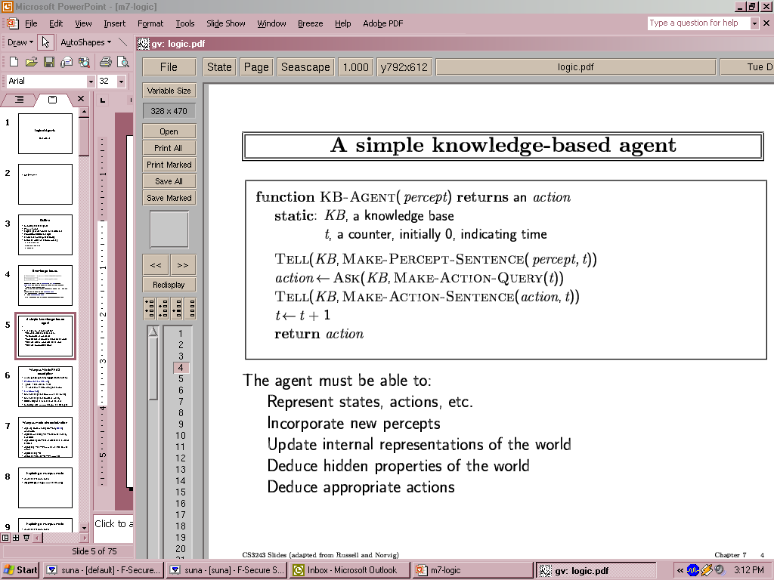

**Problem Statement:**

**The problem involves creating an intelligent system to detect and analyze financial fraud patterns similar to the 1992 Harshad Mehta securities scam. The system needs to:**

1. Model the complex relationships between various actors in the financial system
2. Identify suspicious transaction patterns in the banking and securities markets
3. Track the flow of money through multiple financial instruments
4. Detect regulatory violations in banking and securities trading
5. Flag unusual market manipulation patterns
6. Monitor relationships between brokers, bankers, and other financial actors

**Knowledge Engineering steps applied to chosen problem:**

### 1. Knowledge Acquisition

* **Domain Expert Consultation:**
  + Interview banking professionals
  + Consult market regulators
  + Study historical fraud cases
  + Review financial auditing practices
* **Data Sources:**
  + Bank transaction records
  + Stock market trading data
  + Regulatory compliance reports
  + Banking system documentation
  + Securities market regulations

### 2. Knowledge Organization

* **Ontology Development:**
  + Financial actors (brokers, bankers, regulators)
  + Transaction types (bank receipts, securities trades)
  + Regulatory frameworks
  + Market mechanisms
* **Relationship Mapping:**
  + Transaction flows
  + Reporting hierarchies
  + Regulatory oversight
  + Market interactions

### 3. Knowledge Formalization

* **Logical Framework:**
  + Prolog-based rules for fraud detection
  + Temporal logic for transaction sequences
  + Constraint logic for regulatory compliance
* **Pattern Recognition:**
  + Suspicious transaction patterns
  + Market manipulation indicators
  + Unusual relationship networks

### 4. Knowledge Implementation

* **Rule Base Development:**
  + Fraud detection rules
  + Compliance checking mechanisms
  + Risk assessment metrics
* **Inference Engine Design:**
  + Forward chaining for fraud detection
  + Backward chaining for audit trails
  + Hybrid reasoning for complex cases

**Agent Architecture** *(Justify the blocks)***:**

### 1. Perception Layer

**Justification: Monitors multiple data streams from financial markets**

* Market data sensors
* Transaction monitors
* Regulatory filing trackers
* News feed analyzers

### 2. Knowledge Base Layer

**Justification: Stores domain knowledge and historical patterns**

* Fraud pattern database
* Regulatory rules repository
* Transaction history
* Market behavior models
* Actor relationship networks

### 3. Reasoning Layer

**Justification: Applies rules and detects patterns**

* Pattern matching engine
* Rule-based inference system
* Temporal reasoning module
* Risk assessment engine

### 4. Action Layer

**Justification: Generates alerts and recommendations**

* Alert generation system
* Report generation module
* Investigation recommendation engine
* Regulatory compliance checker

### 5. Learning Layer

**Justification: Improves system performance over time**

* Pattern discovery module
* Rule refinement engine
* Performance optimization
* Feedback incorporation

**CODE:**

% Basic facts about people involved in the scam

person(harshad_mehta, 47, m, stockbroker).

person(banker1, 50, m, bank_manager).

person(banker2, 45, m, bank_employee).

person(regulator1, 55, m, sebi_official).

person(trader1, 40, m, stock_trader).

person(journalist, 35, f, journalist).

% Who was involved in what

involved_in(harshad_mehta, securities_scam).

involved_in(banker1, fraudulent_loans).

involved_in(banker2, fraudulent_loans).

% Who investigated whom

investigated_by(harshad_mehta, regulator1).

investigated_by(banker1, regulator1).

investigated_by(banker2, regulator1).

investigated_by(trader1, regulator1).

% Bribery details

bribed(harshad_mehta, banker1).

bribed(harshad_mehta, banker2).

% Who used fake receipts

used_fake_receipts(harshad_mehta).

used_fake_receipts(banker1).

used_fake_receipts(banker2).

% Market manipulation and profits

manipulated_market(harshad_mehta).

profit_amount(harshad_mehta, 4000).

caused_crisis(securities_scam, banking_system).

exposed_by(journalist, scam_report).

% Rule to find suspects based on involvement

suspect(X) :-

(involved_in(X, securities_scam);

bribed(_, X);

used_fake_receipts(X);

profit_amount(X, _)).

% Rule to identify the main scammer

scammer(X) :-

suspect(X),

manipulated_market(X),

caused_crisis(securities_scam, banking_system).

% Rule to find who exposed the scam

exposed_scam(X) :-

exposed_by(X, scam_report).

**OUTPUT:  
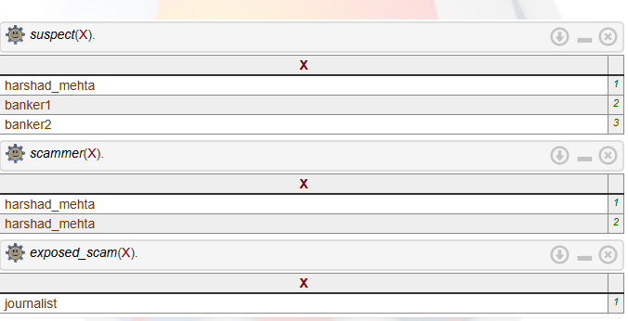**

**Team Members:**

1. **16010122109**
2. **16010122096**

**Post Lab Objective Questions**

**1. Which is not a Goal-based agent?**

1. Inference
2. Search
3. Planning
4. Conclusion
5. Dynamic search.

**Answer: d. Conclusion**

**2. Which were built in such a way that humans had to supply the inputs and  
interpret the outputs?**

1. Agents
2. Sensor
3. AI System
4. Actuators

**Answer: c. AI System**

**Post Lab Subjective Questions**

**Explain the role of PEAS and task environment in choosing the agent architecture. Justify your answer with an example.**

PEAS is Performance measure, Environment, Actuators, and Sensors.

**Performance measure** defines how the agent's performance is assessed.

* **Clue identification** (+5 for finding clues).
* **Wrong suspect** (-8 for incorrectly identifying a suspect).
* **Resolved case** (+10 for closing the case successfully).
* **Open case** (-7 for leaving the case open).
* **Motive identification** (+5 for identifying each motive).

**Environment** refers to the scenario or the external context in which the agent operates.

* **Closed room**: the agent (a data entry person) works in a confined setting, which means the agent has limited physical movement or interaction.
* The data might involve historical crime records, financial data, or scam reports.

**Actuators** are the tools or actions the agent can take to influence the environment.

* **Screen**: where the agent can view information or clues.
* **Printer**: to print reports or summaries after processing clues.

**Sensors** are the devices or mechanisms by which the agent perceives the environment.

* **Keyboard** and **Mouse**: used to interact with the computer interface.
* **Touchscreen**: possibly used for direct interaction or selecting options.
* **Image reader** and **video processor**: to scan images or video footage of financial transactions or relevant evidence, which could help identify scam-related data.

### Task Environment:The task environment influences which agent architecture is chosen.

* The **closed room** environment implies that the agent may work with fixed tools and interact only with data. This suggests a **reactive agent** might be suitable—responding to the data entered rather than performing complex autonomous actions outside of the specified environment.
* Given that the agent might be dealing with both structured (like numerical data) and unstructured data (like scam reports, videos, or images), a **deliberative agent** could be useful if there's a need for planning ( systematically identifying and cross-referencing clues or motives).
* If the data is highly dynamic or changes over time (new cases or evidence are continuously updated), the agent could be more **adaptive**, responding to new data inputs.

### Justification for Choosing the Agent Architecture:

For the bank transaction scam the agent would need:

* **Perception** (through sensors like the keyboard, mouse, image reader) to gather evidence.
* **Processing** (through the actuators like the screen and printer) to analyze and report findings.
* **Learning capabilities** (perhaps incorporating pattern recognition from the identified modus operandi of similar scams or analyzing financial fraud patterns).
* **Decision-making** (based on clues, identifying motives, and correctly identifying suspects).